IA_PCOM7E January 2026
Unit 6 – Development Team Project
Design Proposal Report

Domain: Academic Research Online
Project Type: Agent-Based Intelligent System Development

Module: Intelligent Agents
Assignment Component: Part 1 – Design Proposal Document

Development Team
Othman
Ross
Pitshou
Fatema

1. Domain and Requirements

1.1 Domain Selection and Organisational Goal
The selected domain is Academic Research Online. The organisational goal is to design and implement an intelligent, agent-based system capable of autonomously retrieving academic research results based on defined search terms, processing extracted data (e.g., metadata filtering, classification), and securely storing structured outputs for offline academic analysis. In contrast to static automation scripts, this system adopts an agent-based computing paradigm to enable adaptive behaviour, goal-directed reasoning, and modular collaboration between agents (Hosseini and Seilani, 2025; Sapkota, Roumeliotis and Karkee, 2026).

1.2 Success Criteria
- The agent can autonomously identify and retrieve research results from designated academic platforms.
- The retrieved data is processed (e.g., cleaned, filtered, categorised, formatted).
- The processed information is securely stored and presented in an offline structured format (CSV/JSON/database).
These criteria align with agentic system characteristics including perception, decision-making and action execution (Allmendinger et al., 2026).

1.3 Key Functional Requirements
- Accept defined academic search terms as input.
- Scrape or retrieve structured research metadata (title, authors, year, DOI).
- Extract relevant content fields using parsing methods.
- Perform filtering and validation operations.
- Export structured outputs to an offline repository (local database or file system).
Multi-agent coordination may be implemented (e.g., Retrieval Agent, Processing Agent, Storage Agent) reflecting distributed task models (Crowder et al., 2012).

1.4 Key Non-Functional Requirements
- Security and privacy compliance (respect API limitations and website policies).
- Reliability in handling incomplete or inconsistent data.
- Performance efficiency in large query handling.
- Scalability for additional academic sources.
Agent-in-the-loop mechanisms may enhance reliability by incorporating expert validation processes where necessary (Gao et al., 2025).

1.5 System Requirements
- Programming Language: Python 3.x runtime
- Core Libraries:
  - Requests / BeautifulSoup (data retrieval & parsing)
  - Pandas (data processing)
  - SQLite (offline storage)
  - JSON / CSV utilities
- Optional: Multi-agent design pattern framework

2. Design & Architecture
The proposed design adopts a Hybrid Architecture: a modular, vertically layered pipeline for retrieval, processing, and storage/presentation, with a horizontal orchestration/logging layer across all modules.
The architecture has four modules: Retrieval handles queries, page/API access, and metadata capture; Processing covers parsing, cleaning, validation, and relevance filtering; Storage exports CSV/JSON/SQLite; Orchestration/Logging manages workflow control, retries, rate-limiting, and audit trails.
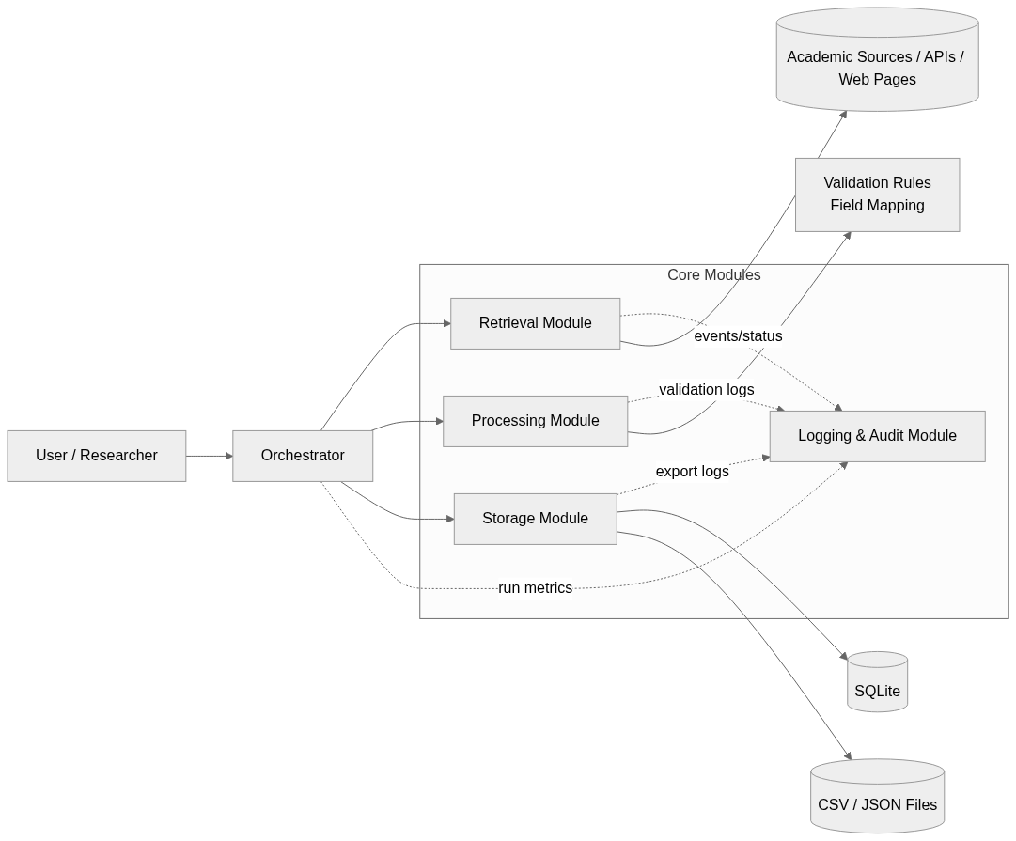
Figure 1: Modular architecture showing orchestration, specialist modules, and storage/logging interfaces.
The agent follows a balanced reactive-deliberative loop: it reactively collects results and responds to failures, while deliberatively assessing coverage and relevance before transforming, saving, and logging outputs. This modular layered design is appropriate because recent multi-agent AI literature emphasises coordinated reasoning, orchestration, and workflow integration rather than fixed linear automation (Allmendinger et al., 2026). Separating concerns makes it easier to add new data-source integrations or validation rules without redesigning the whole pipeline.
When metadata is uncertain, such as a missing DOI or publication year, an agent-in-the-loop checkpoint can request human validation before export, improving quality without complicating the baseline design (Gao et al., 2025). Outputs include a machine-readable dataset and a short summary report for review.
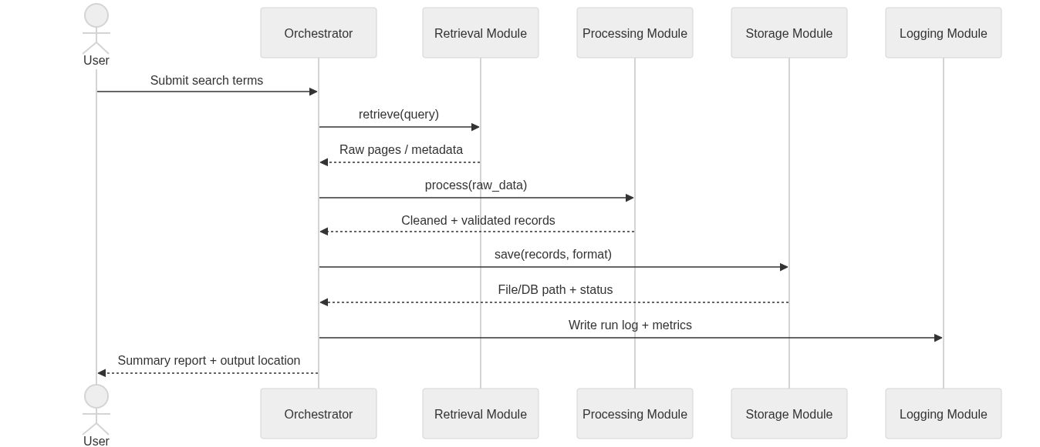
Figure 2: End-to-end agent workflow from query input to offline export and reporting.
This design adopts a single-orchestrator baseline with a clear multi-agent setup path as volume grows. This framing is consistent with recent research that distinguishes modular AI agents from more autonomous agentic systems using multi-agent coordination and persistent memory (Sapkota, Roumeliotis and Karkee, 2026).

3. Approach, Implementation Plan and Challenges
The proposed system adopts an agent-based systems engineering methodology integrating modular design, iterative validation, and goal-directed coordination (Crowder et al., 2012; Allmendinger et al., 2026). Academic search terms are mapped to approved scholarly platforms, and a Retrieval Agent submits structured queries via APIs or compliant HTTP requests. Retrieved metadata (title, authors, year, DOI, abstract) is validated through response monitoring and completeness checks. A Processing Agent performs parsing, deduplication, normalization, relevance filtering, and lightweight classification, assigning confidence scores to support decision-making. Where ambiguity exists, an agent-in-the-loop checkpoint enables optional expert validation (Gao et al., 2025). A Storage Agent exports validated outputs to structured offline formats (CSV, JSON, SQLite), preserving timestamps and query provenance for reproducibility. Logging mechanisms record workflow decisions, retries, and filtering actions to ensure transparency. Performance is evaluated using precision/recall metrics and controlled test queries, enabling iterative refinement (Roumeliotis et al., 2026).
Implementation follows phased Python-based development: environment setup; modular development of retrieval, processing, and storage components; orchestration and logging integration; and systematic testing against defined success criteria. The architecture supports initial single-agent orchestration with scalability toward distributed multi-agent coordination.
Key challenges include API access restrictions and compliance constraints, metadata inconsistency, scalability under high query loads, and system robustness against structural web changes. Additional risks involve secure data storage, synchronisation overhead in multi-agent communication, and balancing human validation with autonomy. Modular architecture, adaptive error handling, and audit logging mitigate these risks while ensuring reliability, ethical compliance, and extensibility for long-term academic research applications.

4. Critical Evaluation and Conclusion

4.1 Key Design Trade-offs
The initial significant design trade-off would be to go with a modular hybrid design with a single orchestrator as opposed to a multi-agent system that is completely decentralised. Although a distributed architecture might improve autonomy and parallel reasoning, it would raise the complexity of coordination, difficulty of debugging and time to develop significantly. In the context of the academic research field, where reliability, traceability, and formalised outputs are of primary importance, the selected modular baseline offers the ability of better workflow control without losing the extension capabilities to a multi-agent implementation in the future.
The second trade-off is API-based retrieval and unlimited web scraping. Web scraping offers coverage but poses legal, ethical and maintenance risks. The approach chosen gives priority to compliant API usage with controlled scraping fallback mechanisms that ensures the suitability of the domain with the flexibility of the approach.
The third trade-off is associated with complete automation and agent-in-the-loop validation. Full autonomous processing is the most efficient, but there is a risk of spreading half-complete or false metadata. Optional validation checkpoints enhance the integrity of data and the academic reliability but at the expense of a limited processing speed. Considering the research-oriented environment, precision is valued more than the raw processing speed.

4.2 Strengths and Weaknesses
The main strengths of the system are that it is modularly extensible, separation of concerns, scalable across academic platforms, and compliant with agent-oriented concepts e.g. perception, reasoning and execution of actions. It is also architecturally capable of supporting secure offline storage and academic analysis that is reproducible.
Limitations, however, are high reliance on the availability of external platforms, the possible API rate limits, and poor semantic comprehension in comparison with advanced NLP-based research assistants. Also, with high query volumes, performance can drop significantly and further optimisation or distributed scaling is not provided.

4.3 Evaluation Metrics
The measures and domain-relevant criteria to be used in evaluation of system success will include:
- Retrieval Accuracy: 90% or higher accuracy of extraction of 3 metadata fields needed (title, authors, year, DOI).
- Processing Reliability: 5% or less validation / formatting error.
- Performance Efficiency: Mean response time at less than specifications of queries per batch.
- Scalability: No system failure due to increases in query load.
- Data Integrity: Structured data properly formatted in CSV /JSON /SQLite and zero cases of corruption.
These measurements guarantee objective, testable validation of the performance of the system and usability in academic contexts.

4.4 Conclusion and Recommendation
The suggested agent-based design offers a powerful and domain-specific concept of autonomous research retrieval and execution of academic research. The system brings reliability through balancing modular control, compliant data access, and validation mechanisms without introducing unnecessary complexity into the architecture. It is proposed that the modular baseline needs to be deployed initially and extended gradually with more comprehensive multi-agent coordination and semantic enrichment being added as the size of the system and the research requirements would allow.

References
Allmendinger, S. et al. (2026) ‘Multi-agent AI’, Electronic Markets, 36(1), p. 18. Available at: https://doi.org/10.1007/s12525-025-00862-z.
Crowder, R. et al. (2012) ‘The development of an agent-based modeling framework for simulating engineering team work’, Systems, Man and Cybernetics, Part A: Systems and Humans, IEEE Transactions on, 42, pp. 1425–1439. Available at: https://doi.org/10.1109/TSMCA.2012.2199304.
Gao, J. et al. (2025) ‘Agent-in-the-loop to distill expert knowledge into artificial intelligence models: a survey’, Artificial Intelligence Review, 58(9), p. 266. Available at: https://doi.org/10.1007/s10462-025-11255-1.
Gao, M. et al. (2025) ‘LLM-based NLG evaluation: current status and challenges’, Computational Linguistics, 51(2), pp. 661–687. Available at: https://doi.org/10.1162/coli_a_00561.
Hosseini, S. and Seilani, H. (2025) ‘The role of agentic AI in shaping a smart future: A systematic review’, Array, 26, p. 100399. Available at: https://doi.org/10.1016/j.array.2025.100399.
Roumeliotis, K.I. et al. (2026) ‘Agentic AI with orchestrator-agent trust: a modular visual classification framework with trust-aware orchestration and RAG-based reasoning’, IEEE Access, 14, pp. 26965–26982. Available at: https://doi.org/10.1109/ACCESS.2026.3662282.
Sapkota, R., Roumeliotis, K.I. and Karkee, M. (2026) ‘AI Agents vs. Agentic AI: A Conceptual taxonomy, applications and challenges’, Information Fusion, 126, p. 103599. Available at: https://doi.org/10.1016/j.inffus.2025.103599.

